4.5 Early Computational Methods

Here we will be looking at methods of multiplication. Studying other methods of multiplication can help us better understand how traditional multiplication works.

Duplation and Mediation: Still used in parts of Russia Today. Duplation refers to doubling one number and mediation refers to halving one number.

Example 1: Multiply 25 × 31 using duplation and mediation.

- Divide the number on the left by 2, drop the remainder, and place the quotient under the number on the left.
- Double the number on the right, and place it under the number on the right.
- Continue this process until 1 appears in the left-hand column
- Cross out all the even numbers in the left-hand column and the corresponding numbers in the right-hand column
- Add remaining numbers in right-hand column

Example 2: Multiply 28 × 22 using duplation and mediation.

Example 3: Multiply 312 × 75 using duplation and mediation.

The Lattice Form of Multiplication: Dates back to the 1200s or before in Europe. It gets its name from the fact that to do the multiplication, you fill in a grid which resembles a lattice one might find ivy growing on. This method uses a rectangle split into columns and rows with each newly-formed rectangle split in half by a diagonal.

Example 4: Multiply 312 × 75 using lattice multiplication.

Example 5: Multiply 469 × 37 using lattice multiplication.

Example 6: Multiply 326 × 189 using lattice multiplication.

Napier’s Rods: Developed in the early 1600s. Proved to be one of the forerunners of the modern-day computer. System of separate rods numbered 0 through 9 and an additional rod for an index, numbered vertically 1 through 9.

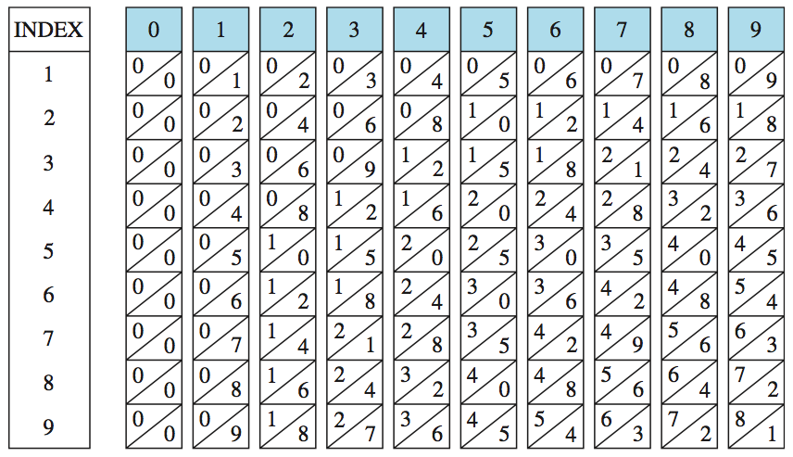

Example 7: Multiply 8 × 345, using Napier’s rods.

Example 8: Multiply 48 × 365, using Napier’s rods.

